Separate storage scenario in Devnet

Tools :

- Docker
- Sector 2 Kb

Configuration :

- Miner (AP, PC1 tasks)
- Worker (PC2, C2 tasks)
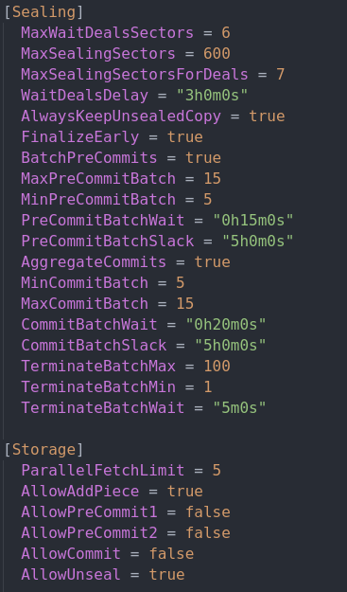

Commands :

- Initialize miner :

lotus-miner init --genesis-miner --actor=t01000 --sector-size=2KiB --pre-sealed-sectors=/root/.genesis-sectors --pre-sealed-metadata=/root/.genesis-sectors/pre-seal-t01000.json –nosync

- Initialize worker:

lotus-worker run --listen "0.0.0.0:3455"

Worker Result :

